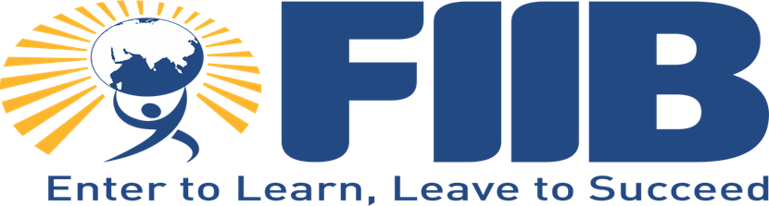

**Fortune Institute of International Business**

**Team Assignment**

**Human Behavior in Organizations**

**Field Based Team Project**



**Introduction**

This report presents insights gathered from an interview with a product manager currently working at Oracle. The manager has over 12 years of professional experience, including 3 years in product management, and previous roles as a technology lead at Wipro and EY. The purpose of this interview was to explore the challenges faced by managers in sustaining teamwork and efficiency, methods used to motivate team members, common conflicts within teams, and essential managerial skills required for effective team management.

**Managerial Background**

* **Current Role**: Product Manager at Oracle.
* **Experience**: 12+ years in the industry, with significant experience as a technology lead and product manager.
* **Responsibilities**: Oversees both product and project management, coordinating with a globally distributed, fully remote team.

**Challenges in Sustaining Teamwork and Efficiency**

* **Remote Teamwork**: The manager leads a team distributed across various time zones, including California and Seattle, which poses challenges in maintaining team cohesion.
* **Key Challenges**:
  + **Time Zone Differences**: Difficulty in synchronizing work hours, leading to potential delays and miscommunications.
  + **Lack of Physical Interaction**: Understanding team members' intentions and body language is harder in a remote setting, affecting team dynamics and efficiency.
* **Solutions**:
  + **Common Ground**: Establishing mutual understanding by identifying shared goals and interests among team members.
  + **Synchronized Work Times**: Coordinating common working hours for better collaboration and task assignment.
  + **Open Communication**: Encouraging open dialogue to ensure clarity and cohesion within the team.

**Long-Term Motivation Strategies**

* **Remote Challenges**: Motivating team members remotely is more difficult compared to an in-office environment.
* **Strategies**:
  + **Virtual Coffee Sessions**: Regular informal meetings to discuss non-work-related topics, helping to build personal connections.
  + **Workshops and Meetups**: Organizing in-person workshops for 2-3 days to foster team bonding and collaboration.
  + **Skill Development**: Identifying and encouraging team members to upgrade their skills, particularly in technology, to stay motivated and relevant.

**Impact of Team Dynamics on Project Outcomes**

* **Example**: Team members often take over tasks for others when time zone differences prevent the original assignee from completing them.
* **Positive Dynamics**: Effective teamwork is demonstrated when team members proactively support each other, especially in critical situations like defect resolution.
* **Personal Experience**: The manager shared an instance where a team member stepped in to resolve an issue, highlighting the importance of adaptability and collective responsibility in achieving project success.

**Approach to Tough Decision-Making**

* **Process**: The manager relies on a critical thinking approach to make tough decisions, focusing on objective analysis and avoiding biases.
* **Key Steps**:
  + **Unbiased Analysis**: Ensuring decisions are fair and based on the problem's merits rather than personal preferences.
  + **Collaborative Decision-Making**: Engaging the team in the decision-making process to ensure all perspectives are considered.

**Managing Underperformance**

* **Skill Upgradation**: The manager provides underperforming team members with additional training and reassessment periods to help them improve.
* **Performance Improvement Plan (PIP)**: If performance does not improve, the manager implements a PIP with specific goals and timelines. Failure to meet these goals may result in role reassignment within the organization.

**Ensuring All Voices Are Heard**

* **Daily Check-ins**: Regular meetings to discuss short-term goals and address current issues.
* **Inclusive Decision-Making**: Involves the team in decisions, often using voting and retrospective meetings to reflect on past work and plan future improvements.
* **Encouraging Openness**: Creating a safe space for team members to express their opinions and ideas freely.

**Recognizing and Rewarding Performance**

* **Formal Recognition**: Corporate awards are given based on specific criteria, but the manager emphasizes the importance of frequent, timely recognition.
* **Personal Approach**: Sending notes of appreciation to team members who have made significant contributions, ensuring that good work is acknowledged regularly.

**Identifying Development Needs**

* **Goal Setting**: Establishing annual goals for team members, followed by regular assessments to track progress and identify areas for improvement.
* **Objective Evaluation**: Using clear performance parameters to make informed decisions about promotions and skill development.

**Implementing Changes Based on Feedback**

* **Example**: In a previous organization, the manager identified inefficiencies due to lack of communication among a diverse team. By fostering better communication and breaking down cultural barriers, team efficiency improved significantly.
* **Team Feedback**: Actively seeking and implementing feedback from team members to enhance overall performance and morale.

**Conclusion**

The insights gathered from this interview provide valuable lessons on managing remote teams, motivating team members, handling conflicts, and making tough decisions. The manager's emphasis on communication, skill development, and unbiased decision-making highlights the critical skills needed to effectively lead a team in a dynamic and challenging environment.